Multiple-choice section

|  |  |  |  |  |  |  |
| --- | --- | --- | --- | --- | --- | --- |
| Question | 1 | 2 | 3 | 4 | 5 | 6 |
| Answer | C | D | C | D | C | C |

Question 1 [7.1]

C

Mark the letters O, A and H on the diagram with *b* as the reference angle.

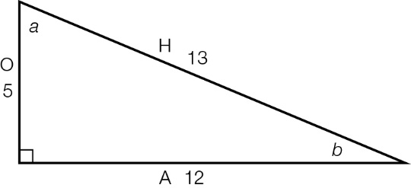



Question 2 [7.2]

D

Mark the letters O, A and H on the diagram.

|  |  |
| --- | --- |
| ACPM9_PR_7_02wsa | sin(*a*) ==  =  *x* = × 27  *x* = 18 |

Question 3 [7.4]

C

Mark the letters O, A and H on the diagram.

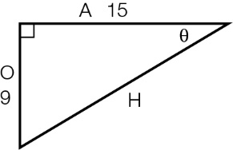

O and A can be used with the tan ratio: tan(θ) =

Question 4 [7.5]

D

Draw the diagram.

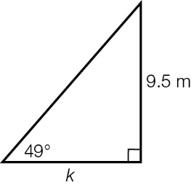

tan(49°) =, so *k* = 

*k* = 8.3 m

Question 5 [7.5]

C

|  |  |
| --- | --- |
|  | The bearing for the return is 20° short of 360°, so it is 340°T. |

Question 6 [7.3]

C

Mark the letters O, A and H on the diagram.

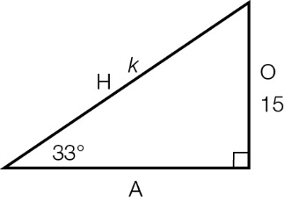

O and H can be used with the sine ratio: sin(33°) = 

Multiple-choice total marks: 6

Short answer section

Question 7 3 marks [7.3]

tan(θ) =

tan(θ) = 

= 27°

Question 8 5 marks [7.1]

**(a)** sin(30°) = 

*h* =  = 12 cm

sin(30°) = 

*H* =  = 16.6 cm

**(b)** These are similar triangles so the ratio of the side lengths will be constant. The hypotenuse is double the length of the opposite side for the angle 30°.

**(c)** Because the hypotenuse is double the length of the opposite side for the angle 30°, the height is half the size of the hypotenuse.

height =  =  = 10.8 cm

Question 9 6 marks [7.3]

|  |  |  |
| --- | --- | --- |
| **(a)**  ACPM9_PR_7_10wsa_RR  sin(θ) =  sin(34°) =  *x* = 5.2 × sin(34°)  *x* = 2.9 m (1 d.p.) | **(b)**  ACPM9_PR_7_11wsa_RR  tan(θ) =  tan(27°) =  *b* =  *b* = 21.2 (1 d.p.) | **(c)**  ACPM9_PR_7_12wsa_RR  cos(θ) =  cos(59°) =  *z* =  *z* = 6.8 (1 d.p.) |

Question 10 6 marks [7.4]

|  |  |  |
| --- | --- | --- |
| (a) sin(θ) =  θ =  θ = 52° | **(b)** tan(θ) =  θ =  θ = 57° | **(c)** cos(θ) =  θ =  θ = 57° |

Question 11 3 marks [7.5]

sin(θ) = 

θ = 20°

sin(20°) = 

*x* = 

*x* = 29.24 ft

Question 12 5 marks [7.5]

Draw a diagram.

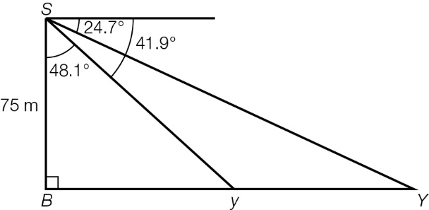

tan(48.1°) = 

*By* = 75 × tan(48.1°)

= 83.588 m

tan(65.3°) = 

*BY* = 75 × tan(65.3°)

= 163.061 m

distance between yachts: 163.061 − 83.588 m = 79.5 m (1 d.p.)

Question 13 6 marks [xx]

length of adjacent side = 25 ft

tan(θ) = 

θ = 15°

tan(15°) = 

*x* = 25 × tan(15°)

*x* = 6.7

θ = 21°

tan(21°) = 

*y* = 25 × tan(21°)

*y* = 9.6

total length of the spaceship = *x* + *y*

= 6.7 + 9.6

= 16.3 ft

Question 14 6 marks [7.3]

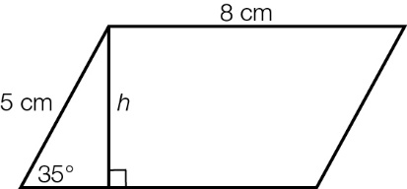

(a) sin(35°) = 

*h* = 5 × sin(35°) = 2.87 cm (2 d.p.)

**(b)** *P* = 2(8 + 5)

= 2 × 13

= 26 cm

**(c)** *A* = base × height

= 8 × 2.867 88

= 22.94 cm2 (2 d.p.)

**(d)** new area: 40 cm2

increase of 17.06 cm2

% increase:  = 74%

Short answer total marks: 40

Extended answer section

Question 15 9 marks [7.5]

|  |  |
| --- | --- |
| (a)  ACPM9_PR_7_16wsa | (b) tan(79°) =  *h* = 7.5 × tan(79°)  *h* = 38.6 m  tan(83°) =  *H* = 7.5 × tan(83°)  *H* = 61.1 m |

**(c)** 7.5 becomes 9.1 so *h* = 46.8 m and *H* = 74.1 m

Question 16 7 marks [7.5]

|  |  |
| --- | --- |
| **(a)**  ACPM9_PR_7_19wsa | **(b)** first leg of journey:  east: cos(55°) =  *e* = 1.6 × cos(55°)  = 0.917 km  second leg of journey:  east: cos(70°) =  *E* = 2.3 × cos(70°)  = 0.786 km  total distance east:  0.917 + 0.786 = 1.7 km (1 d.p.) |

**(c)** first leg of journey:  
north: sin(55°) = 

*n* = 1.6 × sin(55°)   
= 1.310 km

second leg of journey:  
north: sin(70°) = 

*N* = 2.3 × sin(70°)   
= 2.161 km

total distance north:   
1.310 + 2.161 = 3.5 km (1 d.p.)

Extended answer total marks: 16

TOTAL test marks: 62